**05 - List in Python**



**Department of Computer Science and Engineering | Rajalakshmi Engineering College**

**.**

**Ex. No.** **:** **5.1** **Date: 27.04.2024**

**Register No.: 231401100** **Name: Shree Harini S**



**Balanced Array**

**Given an array of numbers, find the index of the smallest array element (the pivot), for which the sums of all elements to the left and to the right are equal. The array may not be reordered.**

**Example**

**arr=[1,2,3,4,6]**

* **the sum of the first three elements, 1+2+3=6. The value of the last element is 6.**
* **Using zero based indexing, arr[3]=4 is the pivot between the two subarrays.**
* **The index of the pivot is 3.**

**Constraints**

* **3 ≤ n ≤ 105**
* **1 ≤ arr[i] ≤ 2 × 104, where 0 ≤ i < n**
* **It is guaranteed that a solution always exists.**

**The first line contains an integer n, the size of the array arr.**

**Each of the next n lines contains an integer, arr[i], where 0 ≤ i < n.**

**Sample Case 0**

**Sample Input 0**

**4**

**1**

**2**

**3**

**3**

**Sample Output 0**

**2**

**Explanation 0**

**The sum of the first two elements, 1+2=3. The value of the last element is 3**

**Using zero based indexing, arr[2]=3 is the pivot between the two subarrays**

**The index of the pivot is 2**

**Sample Case 1**

**Sample Input 1**

**3**

**1**

**2**

**1**

**Sample Output 1**

**1**

**Explanation 1**

**The first and last elements are equal to 1**

**Using zero based indexing, arr[1]=2 is the pivot between the two subarrays**



**Department of Computer Science and Engineering | Rajalakshmi Engineering College**

**.**

**The index of the pivot is 1.**

**For example:**

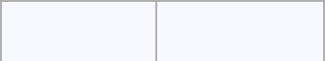

**Input** **Result**

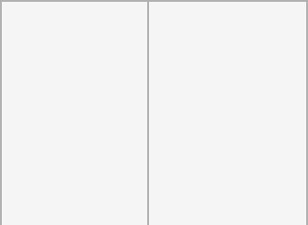

* **2**

**1**

**2**

**3**

**3**



* **1**

**1**

**2**

**1**

**a=int(input())**

**l=[]**

**for i in range(a):**

**c=int(input())**

**l.append(c)**

**for i in range(1,a):**

**d=sum(l[0:i])**

**r=sum(l[i+1:])**

**if(d==r):**

**print(i)**



**Department of Computer Science and Engineering | Rajalakshmi Engineering College**

**.**

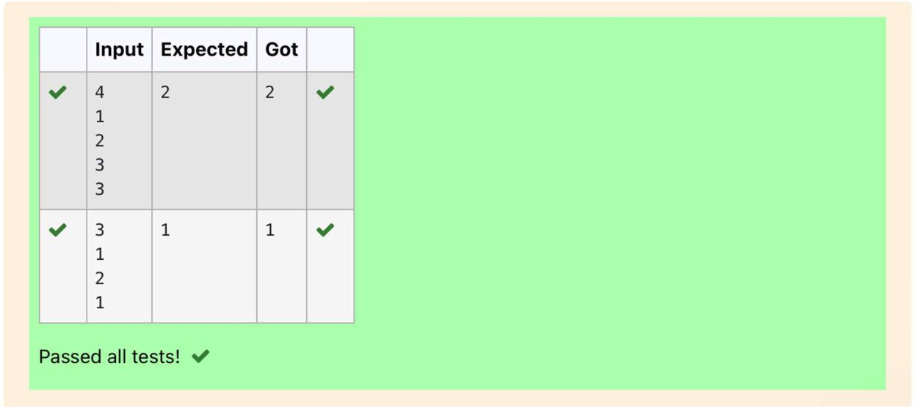

**Department of Computer Science and Engineering | Rajalakshmi Engineering College**

**.**



**Ex. No.** **:** **5.2** **Date: 27.04.2024**

**Register No.: 231401100** **Name: Shree Harini S**



**Check pair with difference k**

**Given an array A of sorted integers and another non negative integer k, find if there exists 2 indices i and j such that A[i] - A[j] = k, i != j.**

**Input Format**

1. **First line is number of test cases T. Following T lines contain:**
2. **N, followed by N integers of the array**
3. **The non-negative integer k**

**Output format**

**Print 1 if such a pair exists and 0 if it doesn’t Input**

**1**

**3**

**1**

**3**

**5**

**4**

**Output:**

**1**

**Input**

**1**

**3**

**1**

**3**

**5**

**99**

**Output**

**0**

**For example:**

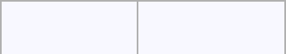

**Input** **Result**



**1** **1**

**3**

**1**

**3**



**Department of Computer Science and Engineering | Rajalakshmi Engineering College**

**.**



**Input** **Result**



**5**

**4**



* **0**

**3**

**3**

**5**

**99**

**a=int(input())**

**while(a!=0):**

**b=int(input())**

**l=[]**

**f=0**

**for i in range(b):**

**c=int(input())**

**l.append(c)**

**k=int(input())**

**a-=1**

**for i in range(b):**

**for j in range(b):**

**if(l[i]-l[j]==k and i!=j):**

**f=1**

**break**

**if(f==1):**

**print(1)**

**else:**

**print(0)**



**Department of Computer Science and Engineering | Rajalakshmi Engineering College**

**.**

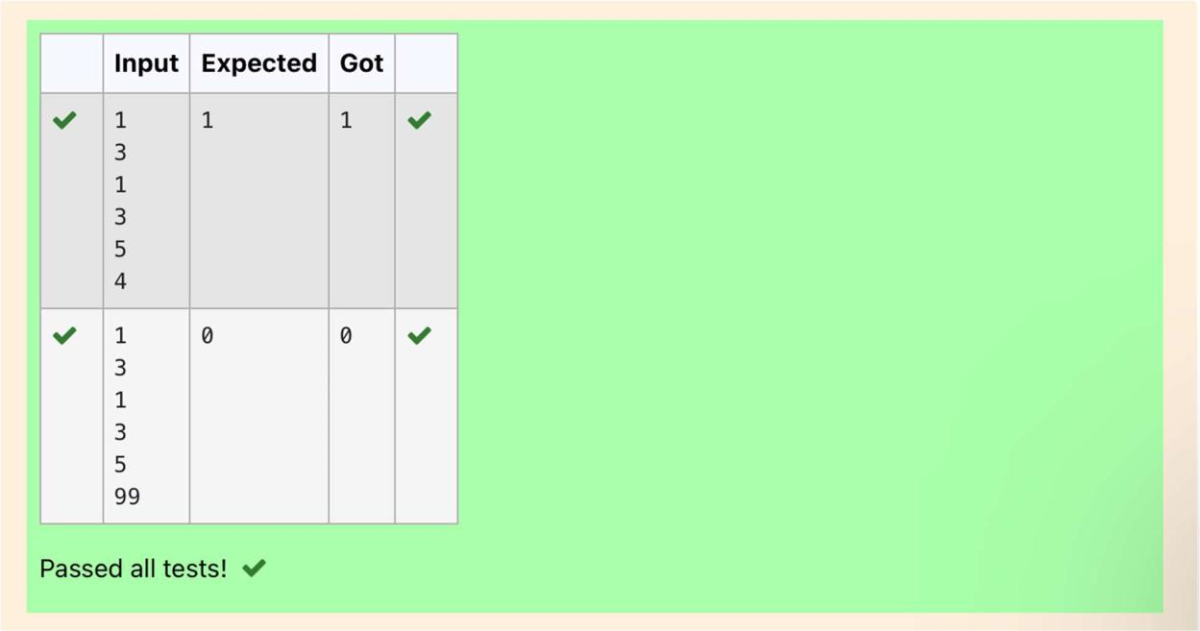

**Department of Computer Science and Engineering | Rajalakshmi Engineering College**

**.**



**Ex. No.** **:** **5.3** **Date: 27.04.2024**

**Register No.: 231401100** **Name: Shree Harini S**



**Count Elements**

**Complete the program to count frequency of each element of an array. Frequency of a particular element will be printed once.**

**Sample Test Cases**

**Test Case 1**

**Input**

**7**

**23**

**45**

**23**

**56**

**45**

**23**

**40**

**Output**

**23 occurs 3 times**

**45 occurs 2 times**

**56 occurs 1 times**

**40 occurs 1 times**

**import collections**

**def CountFrequency(arr):**

**return collections.Counter(arr)**



**Department of Computer Science and Engineering | Rajalakshmi Engineering College**

**.**

**if __name__ == "__main__":**

* **Input size of array n = int(input())**
* **Input elements in array arr = []**

**for _ in range(n): ele = int(input()) arr.append(ele)**

* **Calculate frequency of each element freq = CountFrequency(arr)**

**for key, value in freq.items():**

**print(f"{key} occurs {value} times")**



**Department of Computer Science and Engineering | Rajalakshmi Engineering College**

**.**

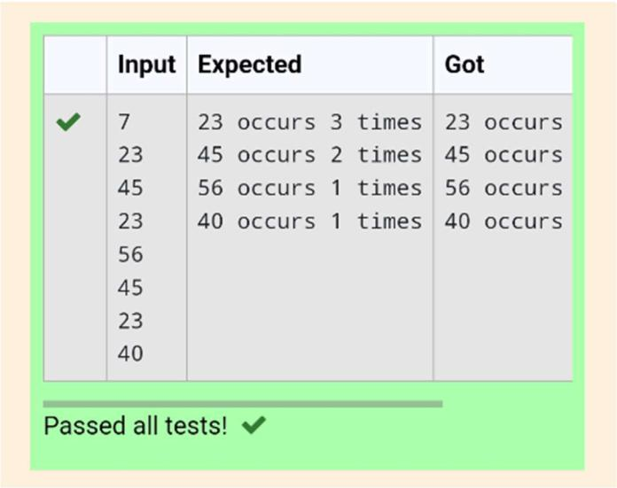

**Department of Computer Science and Engineering | Rajalakshmi Engineering College**

**.**



**Ex. No.** **:** **5.4** **Date: 27.04.2024**

**Register No.: 231401100** **Name: Shree Harini S**



**Distinct Elements in an Array**

**Program to print all the distinct elements in an array. Distinct elements are nothing but the unique (non-duplicate) elements present in the given array. Input Format:**

**First line take an Integer input from stdin which is array length n.**

**Second line take n Integers which is inputs of array.**

**Output Format:**

**Print the Distinct Elements in Array in single line which is space Separated**

**Example Input:**

**5**

**1**

**2**

**2**

**3**

**4**

**Output:**

**1234**

**Example Input:**

**6**

**1**

**1**

**2**

**2**

**3**

**3**

**Output:**

**1 2 3**

**For example:**

**Input Result**

**5**

**1**

**2**

**2**

**3**

**4**

**1234**

**6**

**1**



**Department of Computer Science and Engineering | Rajalakshmi Engineering College**

**.**

**1**

**2**

**2**

**3**

**3**

**1 2 3**

**def merge_arrays_without_duplicates(arr1, arr2):**

* **Combine the arrays and convert to a set to remove duplicates result_set = set(arr1 + arr2)**
* **Convert the set back to a sorted list**

**merged_sorted_array = sorted(result_set)**

**return merged_sorted_array**

* **Input read and processing def process_input():**
  + **Reading number of elements and the elements for the first array n1 = int(input())**

**array1 = []**

**for _ in range(n1): element = int(input()) array1.append(element)**

* + **Reading number of elements and the elements for the second array n2 = int(input())**

**array2 = []**

**for _ in range(n2):**



|  |  |
| --- | --- |
| **Department of Computer Science and Engineering | Rajalakshmi Engineering College** | **.** |
|  |  |



**element = int(input())**

**array2.append(element)**

**# Merge the arrays without duplicates**

**result = merge_arrays_without_duplicates(array1, array2)**

**# Print the result**

**print(" ".join(map(str, result)))**



**Department of Computer Science and Engineering | Rajalakshmi Engineering College**

**.**

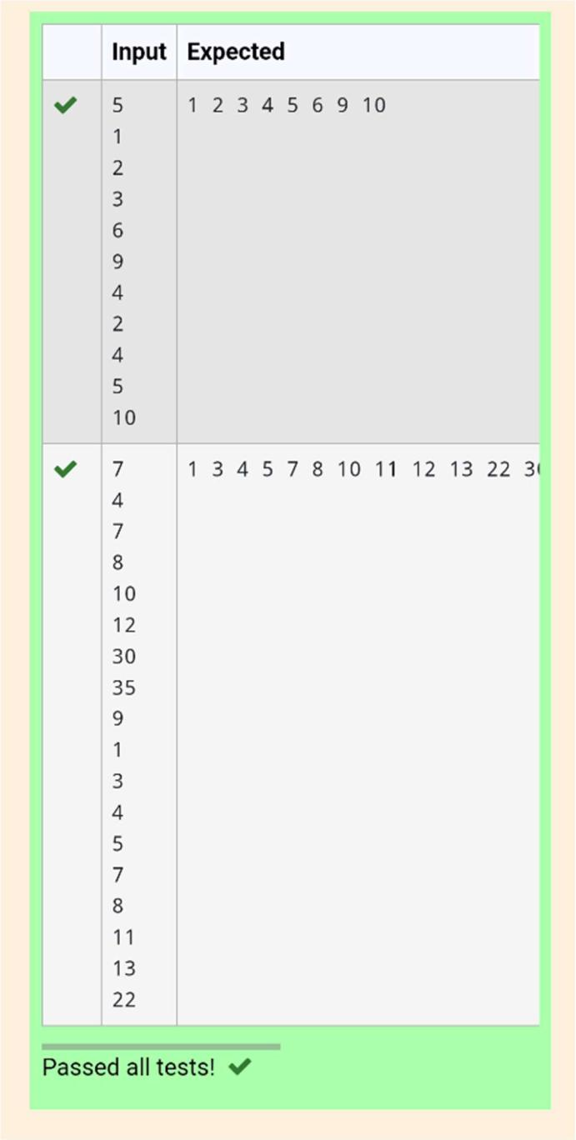

**Department of Computer Science and Engineering | Rajalakshmi Engineering College**

**.**



**Ex. No.** **:** **5.5** **Date: 27.04.2024**

**Register No.: 231401100** **Name: Shree Harini S**



**Element Insertion**

**Consider a program to insert an element / item in the sorted array. Complete the logic by filling up required code in editable section. Consider an array of size 10. The eleventh item is the data is to be inserted.**

|  |  |
| --- | --- |
| **Sample Test Cases** | **33** |
| **Test Case 1** | **55** |
| **Input** | **66** |
| **1** | **77** |
| **3** | **88** |
| **4** | **99** |
| **5** | **110** |
| **6** | **120** |
| **7** | **44** |
| **8** |  |
| **9** | **Output** |
| **10** |  |
| **11** | **ITEM to be inserted:44** |
| **2** | **After insertion array is:** |
|  | **11** |
| **Output** | **22** |
| **ITEM to be inserted:2** | **33** |
| **After insertion array is:** | **44** |
| **1** | **55** |
| **2** | **66** |
| **3** | **77** |
| **4** | **88** |
| **5** | **99** |
| **6** | **110** |
| **7** | **120** |
| **8** |  |
| **9** |  |

|  |  |  |
| --- | --- | --- |
| **10** | **def insert_sorted(list, n):** |  |
| **11** |  |

|  |  |  |
| --- | --- | --- |
|  | **list.append(n)** |  |
| **Test Case 2** | **sorted_list = sorted(list)** |  |
|  |  |
| **Input** | **print("After insertion array is:")** |  |
| **11** |  |
|  |  |
| **22** |  |  |



**Department of Computer Science and Engineering | Rajalakshmi Engineering College**

**.**

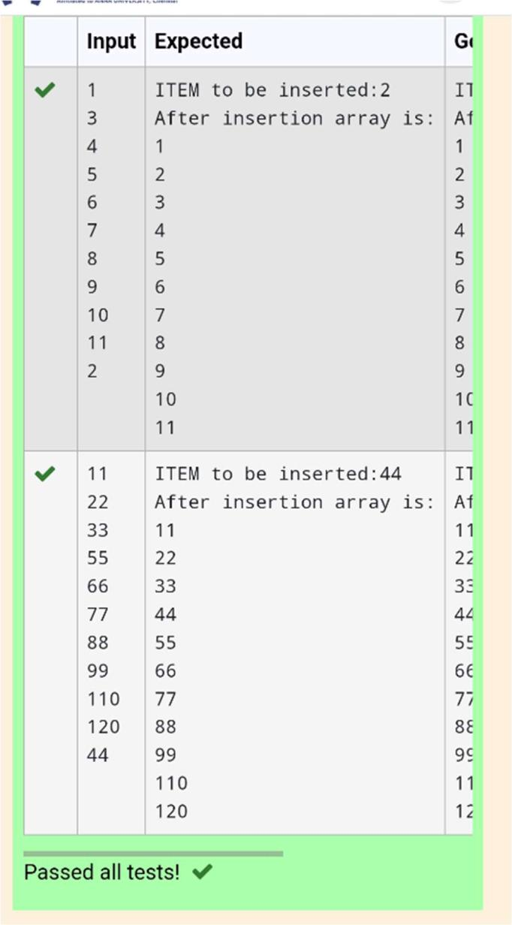

**for i in range(11):**

**print(sorted_list[i])**

**sorted_list = [int(input()) for i in range(10)]**

**new_element = int(input())**

**print("ITEM to be inserted:", new_element, sep='')**

**insert_sorted(sorted_list, new_element)**



**Department of Computer Science and Engineering | Rajalakshmi Engineering College**

**.**

**Ex. No.** **:** **5.6** **Date: 27.04.2024**

**Register No.: 231401100** **Name: Shree Harini S**



**Find the Factor**

**Determine the factors of a number (i.e., all positive integer values that evenly divide into a number) and then return the pth element of the list, sorted ascending. If there is no pth element, return 0.**

**Constraints**

* **≤ n ≤ 1015**
* **≤ p ≤ 109**

**The first line contains an integer n, the number to factor.**

**The second line contains an integer p, the 1-based index of the factor to return.**

**Sample Case 0**

**Sample Input 0**

**10**

**3**

**Sample Output 0**

**5**

**Explanation 0**

**Factoring n = 10 results in {1, 2, 5, 10}. Return the p = 3rd factor, 5, as the answer.**

**Sample Case 1**

**Sample Input 1**

**10**

**5**

**Sample Output 1**

**0**

**Explanation 1**

**Factoring n = 10 results in {1, 2, 5, 10}. There are only 4 factors and p = 5, therefore 0 is returned as the answer.**

**Sample Case 2**

**Sample Input 2**

**1**

**1**

**Sample Output 2**

**1**



**Department of Computer Science and Engineering | Rajalakshmi Engineering College**

**.**

**Explanation 2**

**Factoring n = 1 results in {1}. The p = 1st factor of 1 is returned as the answer.**

**For example:**



**Input** **Result**

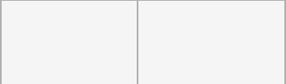

1. **5**

**3**



1. **0**

**5**



|  |  |
| --- | --- |
| **1** | **1** |
| **1** |  |

**import sys**

**import math**

**def find_factors(n):**

**factors = []**

**for i in range(1, int(math.sqrt(n)) + 1):**

**if n % i == 0:**

**factors.append(i)**

**if i != n // i:**

**factors.append(n // i)**

**return sorted(factors)**

**def get_pth_factor(n, p):**

**factors = find_factors(n)**

**if p <= len(factors):**



**Department of Computer Science and Engineering | Rajalakshmi Engineering College**

**.**

**return factors[p - 1]**

**else:**

**return 0**

* **Reading input directly from the standard input (typically for competitive programming)**

**input = sys.stdin.read**

**data = input().split()**

**n = int(data[0])**

**p = int(data[1])**

* **Calculate and print the p-th factor print(get_pth_factor(n, p))**

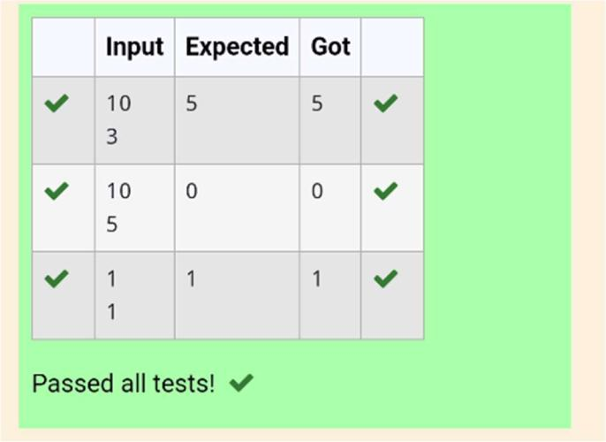

**Department of Computer Science and Engineering | Rajalakshmi Engineering College**

**.**

**Ex. No.**

**:**

**5.7**

**Date: 27.04.2024**

**Register No.: 231401100**

**Name: Shree Harini S**



**Merge List**

**Write a Python program to Zip two given lists of lists.**

**Input:**

**m : row size**

**n: column size**

**list1 and list 2 : Two lists**

**Output**

**Zipped List : List which combined both list1 and list2**

**Sample test case**

**Sample input**

**2**

**2**

**1**

**3**

**5**

**7**

**2**

**4**

**6**

**8**

**Sample Output**

**[[1, 3, 2, 4], [5, 7, 6, 8]]**

**def zip_lists(list1, list2):**

**return [row1 + row2 for row1, row2 in zip(list1, list2)]**



**def main():**

|  |  |
| --- | --- |
| **Department of Computer Science and Engineering | Rajalakshmi Engineering College** | **.** |
|  |  |



**m = int(input())**

**n = int(input())**

**list1 = [[int(input()) for _ in range(n)] for _ in range(m)] list2 = [[int(input()) for _ in range(n)] for _ in range(m)]**

**zipped_list = zip_lists(list1, list2)**

**print(zipped_list)**

**if __name__ == "__main__":**

**main()**

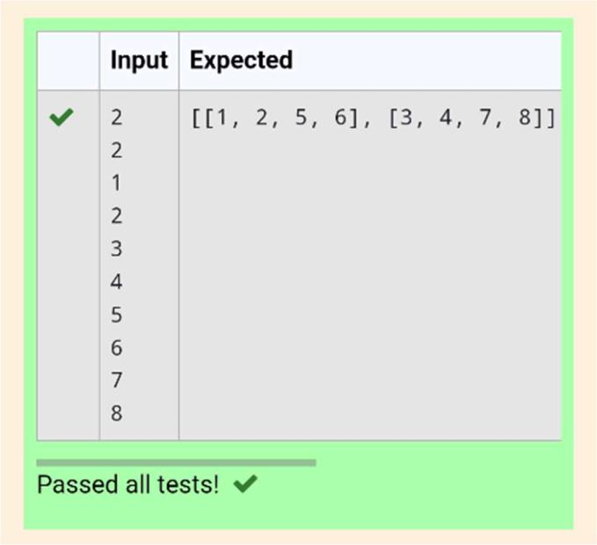

**Department of Computer Science and Engineering | Rajalakshmi Engineering College**

**.**

**Ex. No.**

**:**

**5.8**

**Date: 27.04.2024**

**Register No.: 231401100**

**Name: Shree Harini S**



**Merge Two Sorted Arrays Without Duplication**

**Output is a merged array without duplicates.**

**Input Format**

**N1 - no of elements in array 1**

**Array elements for array 1**

**N2 - no of elements in array 2**

**Array elements for array2**

**Output Format**

**Display the merged array**

**Sample Input 1**

**5**

**1**

**2**

**3**

**6**

**9**

**4**

**2**

**4**

**5**

**10**

**Sample Output 1**

**123456910**

**def merge_arrays_without_duplicates(arr1, arr2):**

* **Combine the arrays and convert to a set to remove duplicates result_set = set(arr1 + arr2)**



|  |  |
| --- | --- |
| **Department of Computer Science and Engineering | Rajalakshmi Engineering College** | **.** |
|  |  |



* + **Convert the set back to a sorted list merged_sorted_array = sorted(result_set) return merged_sorted_array**
* **Input read and processing**

**def process_input():**

* **Reading number of elements and the elements for the first array n1 = int(input())**

**array1 = []**

**for _ in range(n1): element = int(input()) array1.append(element)**

* **Reading number of elements and the elements for the second array n2 = int(input())**

**array2 = []**

**for _ in range(n2): element = int(input()) array2.append(element)**

* **Merge the arrays without duplicates**

**result = merge_arrays_without_duplicates(array1, array2)**

**# Print the result**



|  |  |
| --- | --- |
| **Department of Computer Science and Engineering | Rajalakshmi Engineering College** | **.** |
|  |  |



**print(" ".join(map(str, result)))**

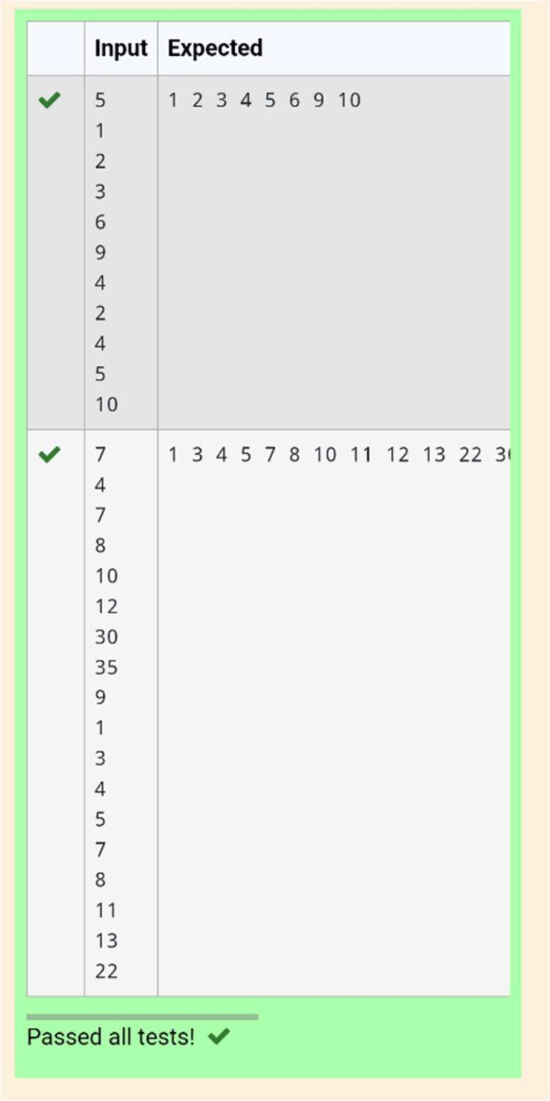

**Department of Computer Science and Engineering | Rajalakshmi Engineering College**

**.**

**Ex. No.** **:** **5.9** **Date: 27.04.2024**

**Register No.: 231401100** **Name: Shree Harini S**



**Print Element Location**

**Write a program to print all the locations at which a particular element (taken as input) is found in a list and also print the total number of times it occurs in the list. The location starts from 1.**

**For example, if there are 4 elements in the array:**

**5**

**6**

**5**

**7**

**If the element to search is 5 then the output will be:**

**5 is present at location 1**

**5 is present at location 3**

**5 is present 2 times in the array.**

**Sample Test Cases**

**Test Case 1**

**Input**

**4**

**5**

**6**

**5**

**7**

**5**

**Output**

**5 is present at location 1.**

**5 is present at location 3.**

**5 is present 2 times in the array.**

**Test Case 2**

**Input**



**Department of Computer Science and Engineering | Rajalakshmi Engineering College**

**.**

**5**

**67**

**80**

**45**

**97**

**100**

**50**

**Output**

**50 is not present in the array.**

**def find_element_locations(lst, target):**

**locations = []**

**count = 0**

**for i in range(len(lst)):**

**if lst[i] == target:**

**locations.append(i + 1)**

**count += 1**

**return locations, count**

**def main():**

**n = int(input())**

**lst = [int(input()) for _ in range(n)]**

**target = int(input())**

**locations, count = find_element_locations(lst, target)**



**if count == 0:**

|  |  |
| --- | --- |
| **Department of Computer Science and Engineering | Rajalakshmi Engineering College** | **.** |
|  |  |



**print(f"{target} is not present in the array.")**

**else:**

**for loc in locations:**

**print(f"{target} is present at location {loc}.")**

**print(f"{target} is present {count} times in the array.")**

**if __name__ == "__main__":**

**main()**

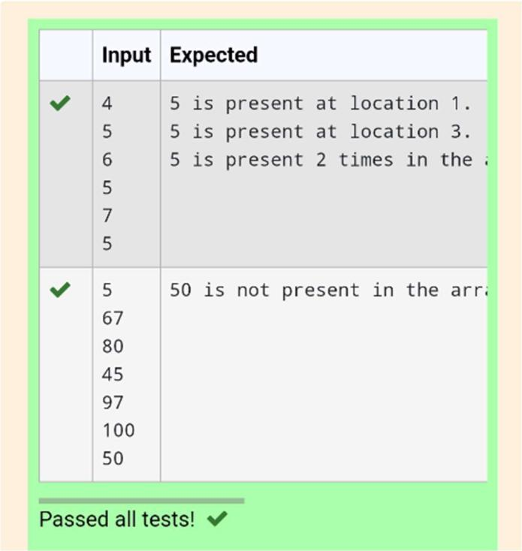

**Department of Computer Science and Engineering | Rajalakshmi Engineering College**

**.**

**Ex. No.** **:** **5.10** **Date: 27.04.2024**

**Register No.: 231401100** **Name: Shree Harini S**



**Strictly increasing**

**Write a Python program to check if a given list is strictly increasing or not. Moreover, If**

**removing only one element from the list results in a strictly increasing list, we still**

**consider the list true**

**Input:**

**n : Number of elements**

**List1: List of values**

**Output**

**Print "True" if list is strictly increasing or decreasing else print "False"**

**Sample Test Case**

**Input**

**7**

**1**

**2**

**3**

**0**

**4**

**5**

**6**

**Output**

**True**

**n= int(input())**



**Department of Computer Science and Engineering | Rajalakshmi Engineering College**

**.**

**arr = [int(input()) for i in range(n)]**

**l = arr.copy()**

**g=0**

**size = len(arr)**

**arr_asc = sorted(arr)**

**arr_des = sorted(arr)[::-1]**

**if arr==arr_asc or arr==arr_des:**

**print('True')**

**g=1**

**else:**

**for i in arr:**

**l.remove(i)**

**arr_asc.remove(i)**

**arr_des.remove(i)**

**if l==arr_asc or l==arr_des:**

**print('True')**

**g=1**

**break**

**l=arr.copy()**

**arr_asc = sorted(arr)**

**arr_des = sorted(arr)[::-1]**

**if g==0:**

**print('False')**



**Department of Computer Science and Engineering | Rajalakshmi Engineering College**

**.**

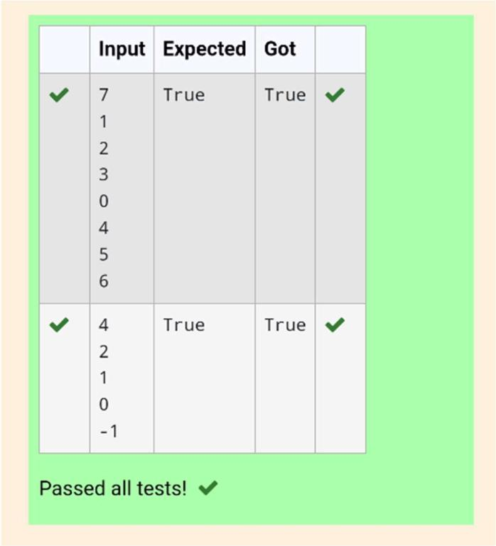

**Department of Computer Science and Engineering | Rajalakshmi Engineering College**

**.**

